Q.write code to create calculator?

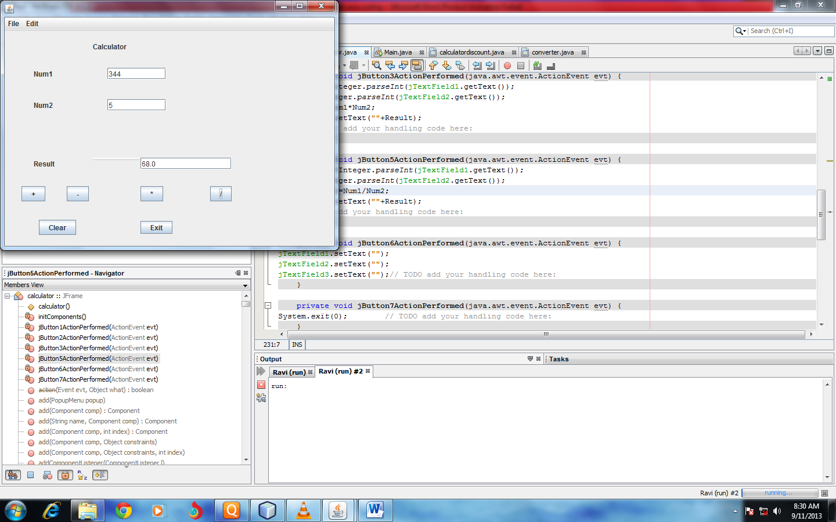

Coding----------------------

private void jButton1ActionPerformed(java.awt.event.ActionEventevt) {

int Num1=Integer.parseInt(jTextField1.getText());

int Num2=Integer.parseInt(jTextField2.getText());

double Result=Num1+Num2;

jTextField3.setText(""+Result);

}

private void jButton2ActionPerformed(java.awt.event.ActionEventevt) {

int Num1=Integer.parseInt(jTextField1.getText());

int Num2=Integer.parseInt(jTextField2.getText());

int Result=Num1-Num2;

jTextField3.setText(""+Result);

// TODO add your handling code here:

}

private void jButton3ActionPerformed(java.awt.event.ActionEventevt) {

int Num1=Integer.parseInt(jTextField1.getText());

int Num2=Integer.parseInt(jTextField2.getText());

int Result=Num1\*Num2;

jTextField3.setText(""+Result);

}

private void jButton5ActionPerformed(java.awt.event.ActionEventevt) {

int Num1=Integer.parseInt(jTextField1.getText());

int Num2=Integer.parseInt(jTextField2.getText());

double Result=Num1/Num2;

jTextField3.setText(""+Result);

}

private void jButton6ActionPerformed(java.awt.event.ActionEventevt) {

jTextField1.setText("");

jTextField2.setText("");

jTextField3.setText(""); }

private void jButton7ActionPerformed(java.awt.event.ActionEventevt) {

System.exit(0);

}